1) Discuss about table tag and row spanning and col spanning.
Ans)
An HTML table has two kinds of cells:
• Header Cells(<th>…..</th>): Contain header information (created with the element).
• Standard Cells(<td>…..</td>): Contain data (created with the td element).
• The text in a th element is bold and centered.
• The text in a td element is regular and left-aligned.
<tr> stands for Table row
<td> stands for table data
<th> stands for table header

Row spanning/Column spanning:
- Use rowspan and colspan attribute either in <td> or <th>element.

<table>
<tr>
<th rowspan=m>Multiple Column Header</th>
<th colspan=n>Multiple Row Header</th>
</tr>
</table>
- m & n are integers specifying number of rows and columns respectively.

2) How to put image for the unordered list.
Ans)
The list items will be marked with an image by using the following attribute:
list-style-image:url(‘logo.gif’);

3) Anchor tag with href and Anchor tag with name property.
Ans)
Example of using the name attribute:
<li><a href="#a001">Jump to a001</a></li>
<h3><a name="a001">a001</a></h3>

4) HTML 5 input type number, email.

Ans)

Input Type Number:
The <input type="number"> defines a numeric input field.
You can also set restrictions on what numbers are accepted.
The following example displays a numeric input field, where you can enter a value from 1 to 5:
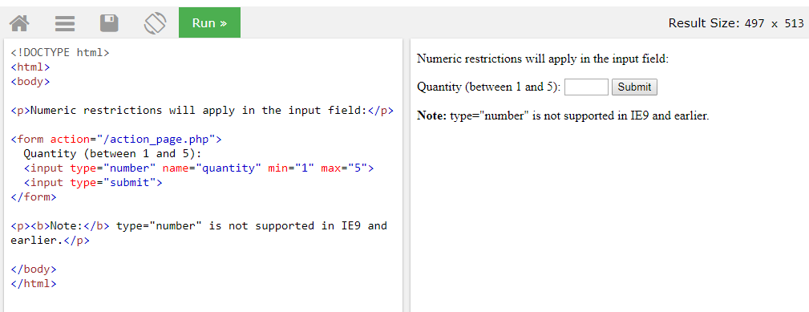

Input Type Email:
The <input type="email"> is used for input fields that should contain an e-mail address.
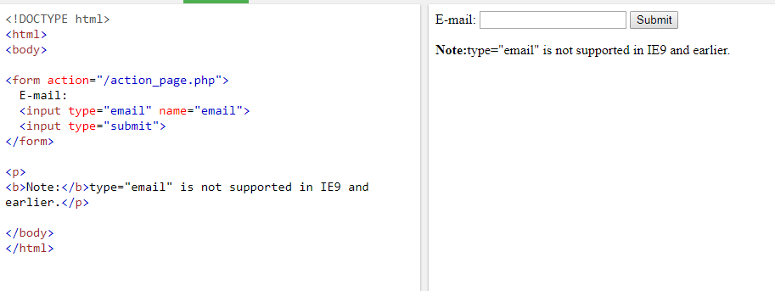

5) Different input type related to date like : date, week etc.

Ans)

Input Type Date:
The <input type="date"> is used for input fields that should contain a date.
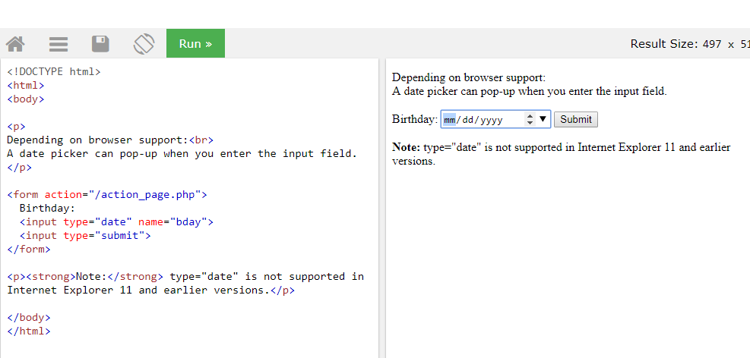

Input Type Week:
The <input type="week"> allows the user to select a week and year.
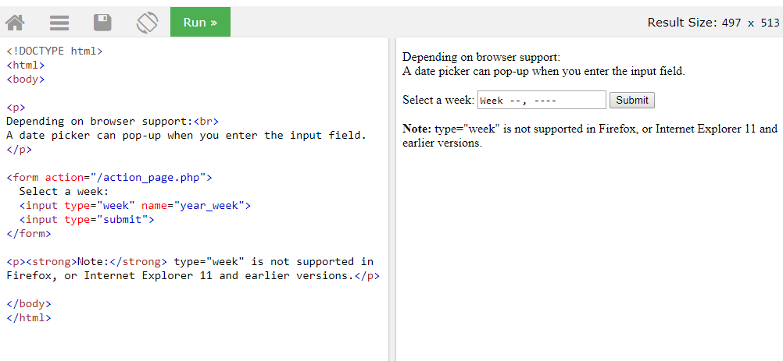

6)Discuss placeholder, autofocus, min, max attribute.

Ans)

The placeholder Attribute
The placeholder attribute specifies a hint that describes the expected value of an input field (a sample value or a short description of the format).
The hint is displayed in the input field before the user enters a value.
The placeholder attribute works with the following input types: text, search, url, tel, email, and password.
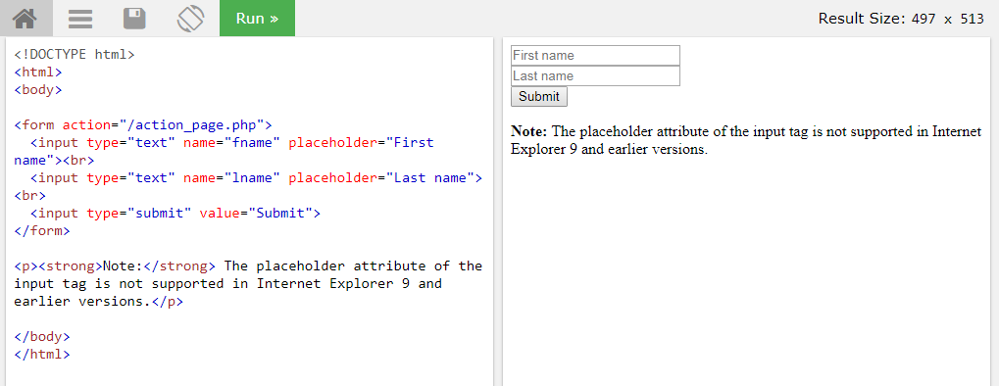

The autofocus Attribute:
The autofocus attribute specifies that the input field should automatically get focus when the page loads.
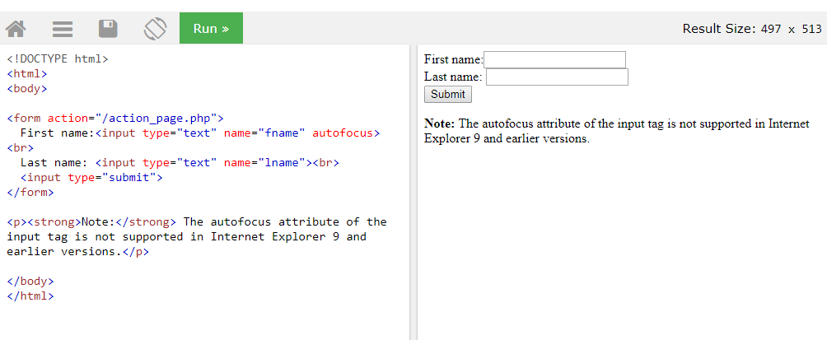

The min and max Attributes:
The min and max attributes specify the minimum and maximum values for an <input> element.
The min and max attributes work with the following input types: number, range, date, datetime-local, month, time and week.
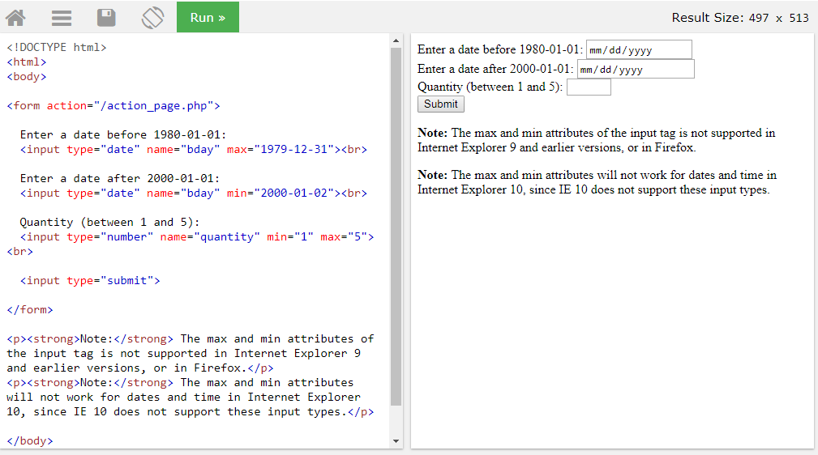

7)New <nav> tag added for navigation menu.

Ans)

Definition and Usage:
The <nav> tag defines a set of navigation links.
Notice that NOT all links of a document should be inside a <nav> element. The <nav> element is intended only for major block of navigation links.
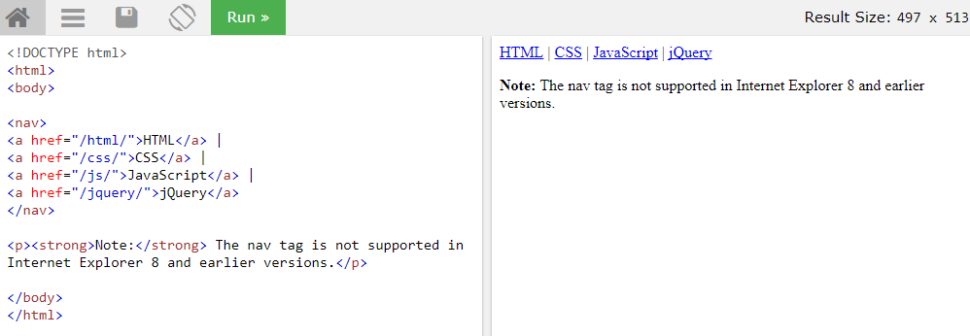

8)<article> tag is used for blogs and posts.
Ans)
Article:
- Represents independent component on page
- Separates itself from other elements on page
- Can be used most efficiently in forum posts, blogs, magazine or newspaper etc.

9)How to specify file type for file upload.
Ans)
Definition and Usage:
The accept attribute specifies the types of files that the server accepts (that can be submitted through a file upload).
Note: The accept attribute can only be used with <input type="file">.
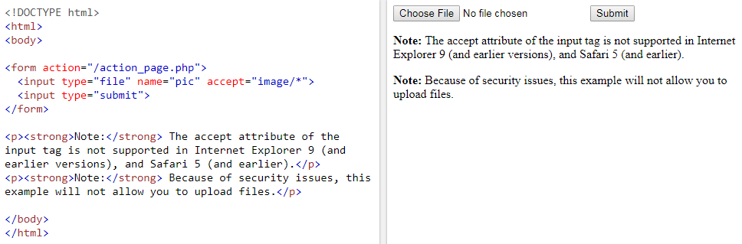

10)How to analyze how many radio button or checkbox selected.
Ans)
Checkbox Element:
- If more than one option is required to be selected from multiple options, then create checkbox as shown below:
<input type=”checkbox”>
(Use checked attribute for selecting any checkbox to be selected by default )

Radio Button:
- If only one option is required to be selected from multiple options, Then create radio button as shown below:
<input type=”radio”>
(Use checked attribute for making a radio button to be selected by default)

